**Name:- Dharan Gowda Superset id:-6387532**

Create a **“.log”** file and a **log folder** in the working directory of Git. Update the **.gitignore** file in such a way that on committing, these files (.log extensions and log folders) are ignored.

Verify if the git status reflects the same about working directory, local repository and git repository.

**1. Go to your Git project folder in Git Bash**

cd /c/Users/Dharan\ Gowda/OneDrive/Desktop/handson-soln/week8/GitProject

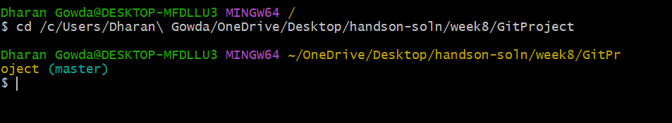

**2. Initialize Git**

git init



**3. Create .log file and log folder**

# Create a top-level .log file

touch debug.log

# Create log folder

mkdir log

# Create a test log file inside log folder

echo "Sample log data" > log/test.log

**4. Create or edit .gitignore**

cat > .gitignore << 'EOF'

# Ignore all .log files

*.log

# Ignore log folder

log/

EOF

**5. Remove already tracked files (only if you committed them before)**

git rm --cached debug.log

git rm -r --cached log/

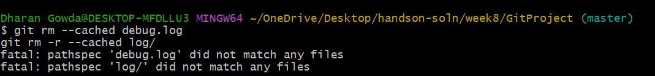

**6. Stage and commit .gitignore**

git add .gitignore

git commit -m "Ignore .log files and log folder"

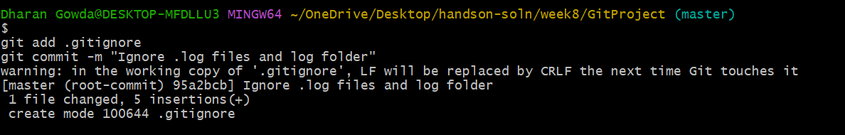

**7. Verify**

# Check Git status

git status

# Show ignored files

git ls-files --others --ignored --exclude-standard

